Contact:
Rick Lenz
RickLenz@RickLenz.com
518-261-1300
http://www.RickLenz.com

Will hidden animosities, demons and secrets kill
completion of the lost John Wayne/James Dean film?
In “Impersonators Anonymous,” a new mystery thriller, a Hollywood producer takes the risk of her life to complete a film, but her face blindness masks reality
Los Angeles, Calif., May 15, 2018 – When actor Rick Lenz starred in John Wayne’s last movie, “The Shootist” in 1976, he asked Wayne about a rumor he’d heard that Wayne had done part of a film called “Showdown” with James Dean.
The question caught Wayne off-guard. He was silent for several seconds and suspected that Richard Boone, another actor who was notable for his roles in Westerns, had leaked news about “Showdown.” When Wayne asked if Lenz had ever worked with Boone, Lenz nodded yes.
Wayne paused again and said, “I don’t talk about that.”
Had Wayne confirmed the rumor? For 30 years, Lenz couldn’t stop thinking about it. In 2007, when the last person who could be hurt by the film had died, Lenz started writing “Impersonators Anonymous,” a mystery thriller prompted by “Showdown.”
The main character, 26-year-old Emily Bennett, an aspiring movie producer, becomes obsessed with completing “Showdown,” which requires using emerging computer technology and doubles who are almost dead ringers for Wayne and Dean. She stumbles into a love triangle with them, but doesn’t know who they really are because she suffers from face blindness, a brain disorder characterized by the inability to recognize faces.
“All three characters emerge from their pasts, gifted but damaged,” Lenz said. “Young and ignorant, they refuse to believe they have power over their lives. Their vengeful ghosts inhabit their every decision, every passion and every dream.”
“Impersonators Anonymous” will appeal to movie buffs and to readers who love a juicy, emotional mystery. (Chromodroid Press, 2018, ISBN: 978-0-9996953-1-9, $16.99, available at RickLenz.com or by emailing RickLenz@RickLenz.com) Preorders will be available in August, 2018 on Amazon and Barnes & Noble …
The novel is also about re-dos – vaulting from the pain, cynicism, even the insanity of youth, onto a whole new track of being.
Lenz weaves the real John Wayne and James Dean into the novel too. They and the other characters find themselves in the titular showdown of their lives. Interwoven back-stories coalesce as they complete the film in a stormy, deadly climax that reveals their hidden animosities and demons.
Read a free sample chapter of “Impersonators Anonymous” at http:/www.ricklenz.com.

ABOUT THE AUTHOR:
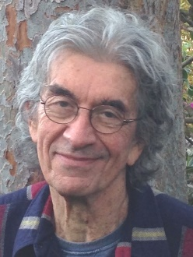
Rick Lenz spent most of his life as an actor, off-Broadway, on Broadway, and in television and film. His movies include “Cactus Flower” (Broadway and the movie), “The Shootist,” “Melvin and Howard.” He starred in other movies and plays with Peter Sellers, Jackie Gleason, Maureen O’Hara, Alan Alda, Jill Clayburgh, Ingrid Bergman, Lauren Bacall, Walter Matthau, Lindsay Wagner, and many more. He starred on stage in Chicago with both Gabor sisters. He is a member of the Academy of Motion Picture Arts & Sciences.
Lenz wrote stage plays that have been produced off-Broadway and on PBS. His first book, “North of Hollywood,” won a Foreword Book of the Year Award and was the first-place memoir in The Los Angeles Book Festival Awards. “The Alexandrite” won the Grand Prize in the Chanticleer Somerset Award for literary and contemporary fiction. It was also named Best Fantasy in the Reader Views Awards.
Lenz is a speaker on the topics of acting, creative writing and the creative arts. He is also an artist and a musician. Discover the creative world of Rick Lenz and read the first chapter of “Impersonators Anonymous” at http:/www.ricklenz.com. Contact Rick at 818-780-1509 or RickLenz@RickLenz.com
###

About the Book:
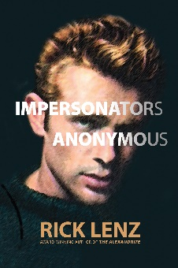
Aspiring movie producer Emily Bennett becomes obsessed with completing “Showdown,” a legendary unfinished movie starring John Wayne and James Dean. She stumbles into a love triangle with her two lead characters who are nearly dead ringers for Wayne and Dean. Her face blindness, a brain disorder that prevents people from recognizing faces, complicates the relationship. These flawed characters, harboring dark secrets, meet the real Wayne and Dean. All find themselves in the titular showdown of their lives when their interwoven back-stories coalesce in a stormy climax that reveals their hidden animosities and demons.
Review Copies and Media Interviews:
For a review copy of Impersonators Anonymous or an interview with Rick Lenz, please contact Chromodroid Press c/o RickLenz@RickLenz.com or (XXX) XXX-XXXX. When requesting a review copy, please provide street address. If you would like to receive this information as a Word document, please let us know.
###

